**Automobile Estore**

**Final Year Project-Mid Report**

**Session 2016-20**

A project submitted in partial fulfilment of the

COMSATS University Islamabad, Lahore Campus Degree

of

BSc. (Hons.) BS in Computer Science (CUI)



Department of Computer Science

COMSATS University Islamabad, Lahore Campus

10 June 2019

**Evaluation:**

|  |  |  |  |  |
| --- | --- | --- | --- | --- |
| **Project Group Members** (To be filled by students) | | | | (To be filled by supervisor) |
| Sr.# | Reg. # | Student Name | *Signature | Obtained Marks  (Total Marks: 10) |
| (i) | FA16-BCS-318 | Zaid Ul haq |  |  |
| (ii) | FA16-BCS-330 | Salman Ali |  |  |

*The candidates confirm that the work submitted is their own and appropriate credit has been given where reference has been made to work of others.

Supervisor Name: ______**Dr. Imran Latif** _ Supervisor Signature: ______________

Remarks (if any): ______________________________________________________________

______________________________________________________________

______________________________________________________________

# Abstract:

At present people are trying to save their time by searching things online that can be delivered directly at their doorstep. When it comes to Japanese car spare parts, you cannot find it in the market that easy, if you may find it chances are it can be, fake or the shopkeeper may be charging you way more than the original price. That’s how we got to an idea of an online spare parts website where you can find all kind of spare parts for your vehicle especially for Japanese cars. You don’t have to waste your whole day going out in search of a specific auto part, you just have to write your car name, select your price range, add your address and that’s it, you are done. It will be delivered at your doorstep. Also, mechanics for these type of vehicles are hard to find because of their complex interior design and computerised engine. So, with the help of our website you can easily search the area where you are and we would show you the best mechanics available in that area and also their ratings so you can choose it by yourself and just go at that address. The new thing in our project is that you can also find data of some of the popular platforms in our website so you can find the things that are not available in our website in those stores. You can easily compare the prices of the products of those websites. It would make your life much easier.

Table of Content:

Abstract: 3

1 Introduction 6

1.1 Idea 6

1.2 Objectives 7

1.3 Problem statement 7

1.4 Assumptions & constraints 8

1.4.1 Assumptions 8

1.4.2 Constraints 8

1.5 Project scope 8

2 Requirements Analysis 9

2.1 Literature review 9

2.2 Stakeholders list 9

2.3 Requirements elicitation 9

2.3.1 Functional requirements 9

2.3.2 Non-functional requirement: 10

2.3.3 Requirements traceability matrix: 10

2.4 Use case descriptions 13

2.5 Use case diagrams: 20

2.5.1 Admin Uses-Case Diagram 20

2.5.2 Customer Uses-Case Diagram 21

2.5.3 Inventory kit Use-case Diagram 25

2.6 Software development life cycle 27

2.7 Sequence diagram 27

2.8 Software architecture 45

2.9 Database diagram 46

2.10 Work Breakdown Structure 47

2.11 Gantt chart 48

3 Conclusion 48

3.1 Problems faced 48

3.2 Project summary 49

3.3 Future work 49

**List of Figure:**

Figure 1:Admin Panel 20

Figure 5:Customer Dashboard 21

Figure 6: Login, Signup, View Product 22

Figure 8:WishList 23

Figure 13:Supplier(manage product and Customers) 24

Figure 14:Inventory Dashboard 25

Figure 18:Spiral Model Diagram 27

Figure 20: Cash on Delivery (Sequence Diagram) 28

Figure 21:Cart(Sequence Diagram) 29

Figure 23:Customer Chat (Sequence Chat) 30

Figure 26:Item(Sequence Diagram) 31

Figure 27:Login (Sequence Diagram) 32

Figure 32:Search(Sequence Diagram) 33

Figure 33:SignUp(Sequence Diagram) 34

Figure 35:View Brands (Sequence Diagram) 35

Figure 37:View Customer (Sequence Diagram) 36

Figure 41:View Orders (Sequence Diagram) 37

Figure 42:WishList(Sequence Diagram) 38

Figure 46:Add Product 40

Figure 49:WishList 41

Figure 50:Contact us 42

Figure 52:SignUp 43

Figure 53:Login 44

Figure 54:System Architecture Diagram 45

Figure 55:ERD 46

Figure 56:WBS 47

Figure 57:Gantt chart 48

**List of Tables:**

**Table 1: Requirement Traceability Matrix** 10

**Table 2: Login Use Case Description** 13

**Table 3: View Purchased Item Use Case Description** 14

**Table 4: Sign Up Use Case Description** 15

**Table 7: View Order Use Case Description** 16

**Table 8: Search Use Case Description** 17

**Table 14: View brand Use Case Description** 18

**Table 16: View Inventory Use Case Description** 19

# Introduction

## Idea

The idea is related to web-based Application having friendly interface with android, which is for now mainly for Pakistani Market. In recent times, people find it very difficult to have reliable product and product of their cars. Therefore, the aim of idea is to build such Application, which ensure people’s trust and facilitate them with products, which are not in other e-commerce sites. It will save their precious time, which is the key factor in recent times. Its salient features are discussed below:

1. This idea provides Consumer to Consumer, Business to Business and Business to Consumer (B2B, C2C, B2C) sales service web-based Application, as well as shopping search engines.

2. Idea will help people to do window-shopping of their cars spare parts or other accessories without going in the market.

3. Idea will convert Yellow pages directory to a simple mobile friendly web-based application where people can have details of all cars auto parts shops location, type of service, nature, name, contact number, timings, offers etc.

4. Customers can have opportunity to save their waiting time of delivery, can avail discounts and offers at their place, can save time of visiting market, and can have high quality products.

5. Our website would save your time to search for the great mechanics near you that would do the repair work smoothly and would not harm your car.

7. This idea will not just overcome the problems of customers and spare part brands but also it will help brands to improve their business with application by using different kind of services.

8. This idea will let people increase growth of their business by advertising their business on our website and it will give benefits to customers and brands.

9. The idea will provide all that car accessories for customers on demand which they can’t find anywhere in the market.

## Objectives

* Ecommerce site, app which tackles and captures the brand market (as supplier) or local market
* Register by just adding a low info get the ecommerce sites and local site and application.
* Search the product location wise.
* Delivery within 24 hr.
* Design of the site must be so easy and cooperative

## Problem statement

Start with concept of the market, initially there were only limited shop around the area but then the concept of Mart appears then super Mart. People move toward Super Mart after that there occur the concept of ecommerce. There decline in the revenue of those shopkeeper because they not change according to the time (issue cause opportunity) so, if we provide them the opportunity to sell their product online, they can easily boost up their revenue. There is a lot of opportunity because a lot of market is still not converted to online. Analysis of the local market shows that the average revenue become down since 10-year people move toward the brand and the online store to meet.

## Assumptions & constraints

### Assumptions

* The website needs operating cost.
* This proposed website will require registration to post an ads.
* This proposed website required internet availability.
* This proposed website required operating system and a running internet browser.
* This proposed website will not violate any ethical and culture rules.
* We have to pay cost of advertisement the website need.
* The website need cost to work on user requirement and updates.

### Constraints

* Estimated website traffic
* The risk of giving payment through debit/credit card.
* No customer can view product physically they can only visualize it.
* The developer team needs to update their technology to latest one.
* Insufficient telecommunication bandwidth.

## Project scope

In recent times people are finding it difficult to find the auto spare parts online, some of the brands have their online store but no website or application have all the brands.

• This idea will build a trustworthy service that will ensure quality, time efficiency, win-win relationship, branded items.

• This idea helps brands to increase their earning with different kind of facilities.

• The idea will target more audience by targeting more products gradually that will help us to make our image in market.

• The project is based on many courses that we have studied in last three years, like Database, FCP, Design and analysis of Algorithm, Operating System, Networks, Object oriented programming, Management, Entrepreneurship, Report Writing, Machine Learning etc

# Requirements Analysis

## Literature review

As the analysis, it concludes that this type of project must need in market to enhance the mobility of the market with in the hand of the peoples. Therefore, People can locate the products and purchase it, this project helps to increase the revenue of the local investor by providing them low cost services. It provides online spare parts and mechanics loaction. In the results, it saves the customers time by giving them all the spare parts online providing the information about their relevant car mechanics.

## Stakeholders list

* + 1. Admin
    2. Project Development Team
    3. Customers
    4. Suppliers
    5. Employees

## Requirements elicitation

### Functional requirements

Functional Requirements are as under.

* Register the account.
* Site would be responsive.
* Allow users (Customer and Supplier) to login.
* Ability to allow admin to set registration permissions for new users.
* Ability to let the users view their profiles.
* Ability to allow users update their profiles.
* Easy to update, add, delete, edit products.
* Add video and ads in the website.
* Blog area on the website for latest news
* Email marketing and Sign up.
* Website with good SEO.
* This project according to categories, popularity and duration.
* The project will allow Users to save their liked products.
* The project will allow User to view and update the status of their profile.
* The project will allow Users to manage their account, in terms of Username, Password and Project Status.

### Non-functional requirement:

Non-Functional requirements for this project are:

* Provide the multilevel of security
* Provide the Privacy to each users and admin.
* Provide the site that scale to meet expected traffic and even in peak times so the customer can easily do shopping.
* Site must be Responsive.
* Use technique through future development feasible.
* Sites responsive time minimum
* Performance of the site be high

### Requirements traceability matrix:

**Table 1: Requirement Traceability Matrix**

|  |  |  |  |
| --- | --- | --- | --- |
| Requirement NO | Description of Requirement | Objective | Deliverables |
| 01 | System will provide accounts to customers, brands and admins. | Creating account. | Registration. |
| 02 | User can login in the system. | Logging user account. | Login. |
| 03 | The system shall include complaint section. | Registering and managing Complaints. | Compliant Section. |
| 04 | System will provide products details. | View Details of the Product. | Product Section. |
| 05 | System will provide online payment gateway. | Paying online payment. | Online Payment Module. |
| 06 | System will provide wish list. | Viewing and managing wish list. | Wish list. |
| 07 | System will provide cart option. | Managing and viewing cart. | Cart. |
| 08 | System will provide search engine. | Searching product or viewing history. | Search bar. |
| 09 | System will provide editable profile details. | Updating or deleting personal information. | User account. |
| 10 | System include products section to add, update and delete. | Adding new product, updating and deleting. | Products. |
| 12 | System include newsletter subscription. | Entering email to subscribe. | Newsletter subscription. |
| 13 | System will provide feature of contacting admins. | Contact using email and phone number. | Contact us. |
| 17 | System include feature of adding product to shopping cart. | Adding product to shopping cart. | Shopping cart. |
| 18 | System include feature of adding product to wish list. | Adding product to wish list. | Wish list. |
| 19 | System include viewing orders. | View, update and delete order. | Orders. |
| 20 | System include tracking order. | Viewing status of the order. | Tracking orders. |

**Description:**

This Table use to check that our project-working graph met our requirements or not.

## Use case descriptions

**Table 2: Login Use Case Description**

|  |  |
| --- | --- |
| **Use-Case: Login** | |
| **Actors:** Admin, Employees, Customer, Supplier | |
| **Use-Case Summary:** User will be able to login to the Website | |
| **Pre-Condition:** User should be sign Up. | |
| **Core Event** | **Alternative Path** |
| User will click on the login button. |  |
| User will fill the username and password fields. | **2a**. User can select remember me Checkbox.  **2b.** In case of forget password, user confirm his/her email.  **2c.** If email is correct then user will receive new password otherwise show message email is incorrect. |
| On verification, user will be  logged in. |  |
| **Post-Condition:** User’s will be successfully logged in, to the application. | |

**Description:**

This Table contain the entire requirement for the login and action result for after login.

**Table 3****: View Purchased Item Use Case Description**

|  |  |
| --- | --- |
| **Use-Case: Add Order** | |
| **Actors: Supplier** | |
| **Use-Case Summary:** User will be able to add and modify product. | |
| **Pre-Condition:** User must have to log-in. | |
| **Core Event** | **Alternative Path** |
| User clicks on Add Order. | 1a. User can add and modify product.  1b. User can check their stock. |
| **Post-Condition:** User can control add order. | |

**Description:**

This Table shows that the description that which requirement are necessary/ to order a product.

**Table 4: Sign Up Use Case Description**

|  |  |
| --- | --- |
| **Use-Case: Sign Up** | |
| **Actors:** Customer, Supplier | |
| **Use-Case Summary:** User will be able to Sign-Up to the Website | |
| **Pre-Condition:** User should be on website. | |
| **Core Event** | **Alternative Path** |
| User should browser on our site. |  |
| User went on the Sign-Up Screen. |  |
| User will provide all the Personal details for registration. | 3a. User can also register himself via google or Facebook etc |
| On verification of details the user can sign-Up |  |
| **Post-Condition:** User’s will be successfully Sign Up, to the Website. | |

**Description:**

This Table describe how the option of sign up or register will work in our site. What type of parameter require for it.

**Table 7: View Order Use Case Description**

|  |  |
| --- | --- |
| **Use-Case: View Order** | |
| **Actors:** Admin | |
| **Use-Case Summary:** User will be able to view all Order on the website. | |
| **Pre-Condition:** User should be registered. | |
| **Core Event** | **Alternative Path** |
| User click on the View Order button. |  |
| User can see List of Orders. | User Search for Order. |
| **Post-Condition:** User have access to all Order. | |

**Description:**

This Table show that admin have the accessibility to view the details about the new and the past orders.

**Table 8: Search Use Case Description**

|  |  |
| --- | --- |
| **Use-Case: Search** | |
| **Actors:** Admin, Customer, Brands. | |
| **Use-Case Summary:** User will be able to Search the website. | |
| **Pre-Condition:** User can be any one with internet access. | |
| **Core Event** | **Alternative Path** |
| User click on the Search button. | User can choose category. |
| User can enter keyword. | User can click on previous history. |
| **Post-Condition:** Result of Search appear to user. | |

**Description:**

This Table show that admin, supplier and customer have the accessibility to search, whether everyone have different limitation on searching. Customer can search items and products; supplier can search about features in its store while the admin can search about features as well.

**Table 14: View brand Use Case Description**

|  |  |
| --- | --- |
| **Use-Case: View Brands** | |
| **Actors:** Admin | |
| **Use-Case Summary:** User will be able to view all brands registered on the website. | |
| **Pre-Condition:** User should be registered. | |
| **Core Event** | **Alternative Path** |
| User click on the View Brands button |  |
| User can see List of Brands | User Search for brand |
| **Post-Condition:** User have access to all register’s brands. | |

**Description:**

This Table show that admin have the accessibility to register the brands store.

**Table 16: View Inventory Use Case Description**

|  |  |
| --- | --- |
| **Use-Case: View Inventory** | |
| **Actors: Supplier, Brand** | |
| **Use-Case Summary:** User will be able to add and modify product. | |
| **Pre-Condition:** User must have to log in. | |
| **Core Event** | **Alternative Path** |
| User clicks on inventory. | 1a. User can add and modify product.  1b. User can check their stock. |
| **Post-Condition:** User can control inventory system. | |

**Description:**

This Table show that admin can view the inventory and stock.

## Use case diagrams:

### Admin Uses-Case Diagram

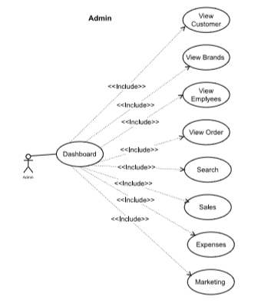

Figure 1:Admin Panel

**Description:**

This Figure show the use case diagram of Admin Panel.

### Customer Uses-Case Diagram

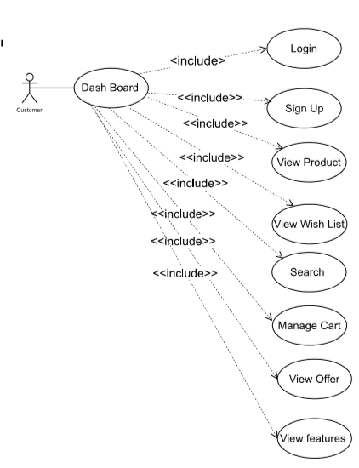

Figure 5:Customer Dashboard

**Description:**

This Figure show the use case diagram of Customer Dashboard.

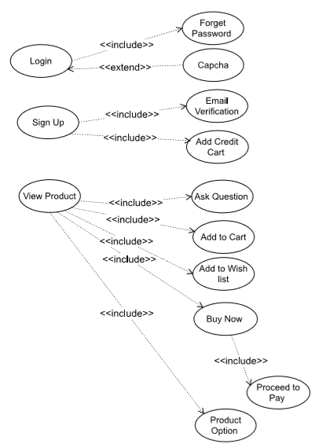

Figure 6: Login, Signup, View Product

**Description:**

This Figure show the use case diagram of Login, Sign Up.

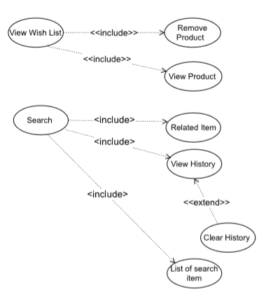

Figure 8:WishList

**Description:**

This Figure show the use case diagram of Wishlist.

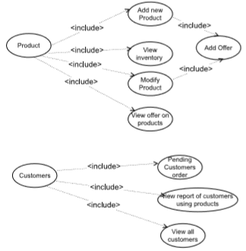

Figure 13:Supplier(manage product and Customers)

**Description:**

This Figure show the use case diagram of product and the customer in the supplier panel.

### Inventory kit Use-case Diagram

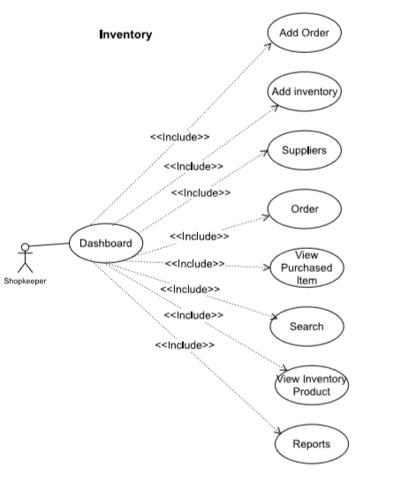

Figure 14:Inventory Dashboard

**Description:**

This Figure 14 shows the use case diagram of Inventory Dashboard

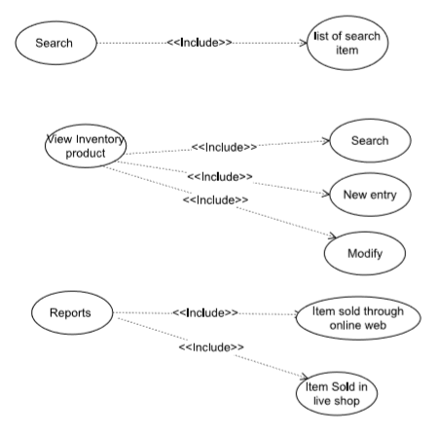

Figure 15: Search Report

:

**Description:**

This Figure show the use case diagram of report, search, view inventory product.

## Software development life cycle

Spiral Model is the life cycle we are using in our project.

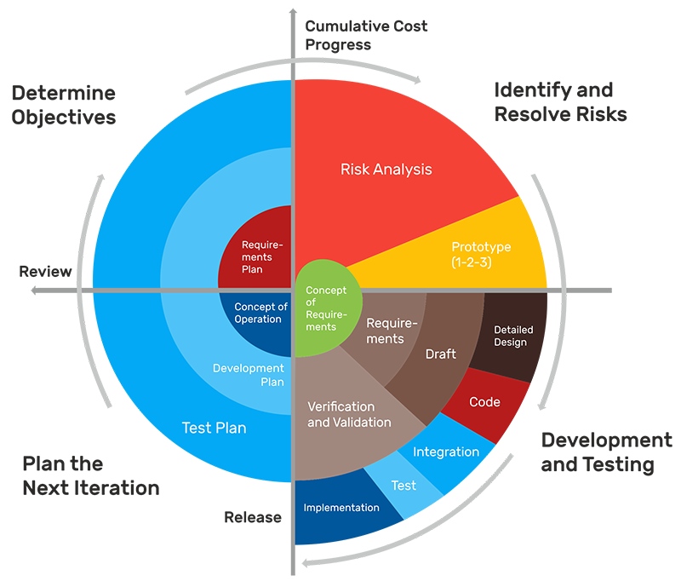

Figure 18:Spiral Model Diagram

**Reasons:** Requirements for this project not very be very simple. During development phase if the requirement changes, it may affect the development of our project. So, the risk during the development of this project can be reduced by using this spiral model. As the spiral model is risk-driven, it can calculate risk and its iterative technique help to adopt the new requirement into the possible upcoming solution in the project. This model gives the facility to minimize the cost and we can add additional function at future date.

## Sequence diagram

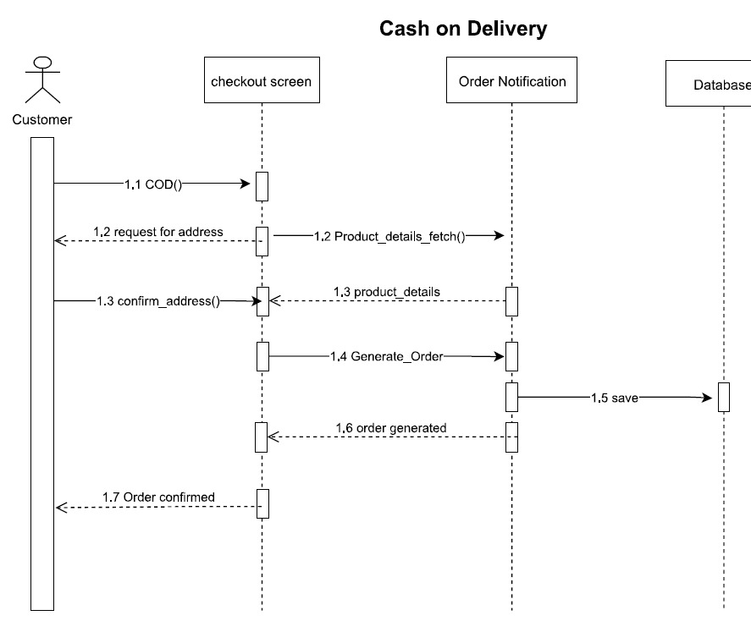

Figure 20: Cash on Delivery (Sequence Diagram)

**Description:**

This Figure show the sequence how the query for COD(cash on delivery) will work within the system.

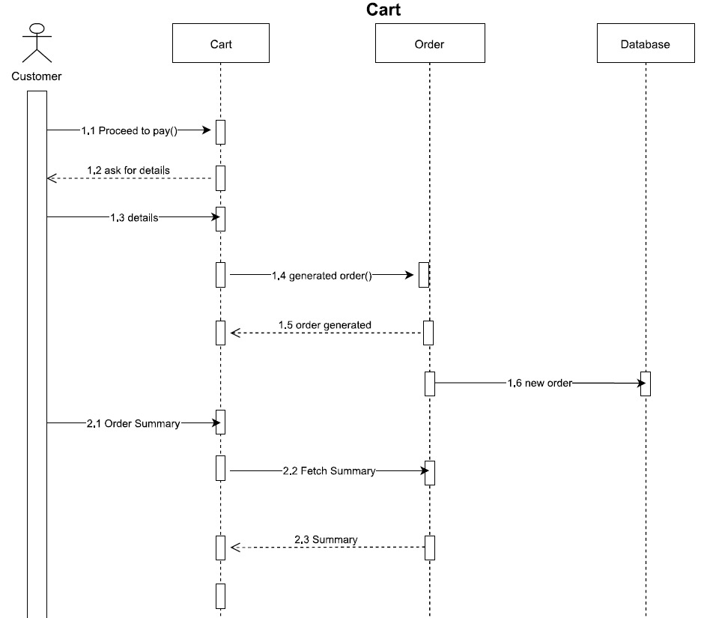

Figure 21:Cart(Sequence Diagram)

**Description:**

This Figure show the sequence how the query to add a product in cart will work within the system.

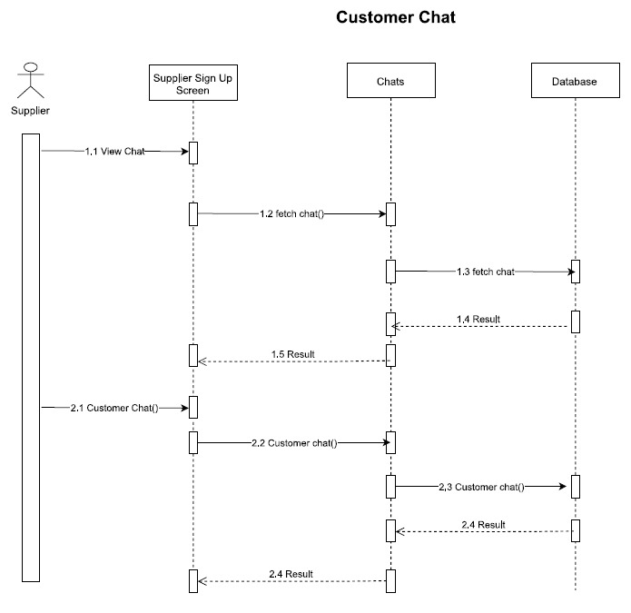

Figure 23:Customer Chat (Sequence Chat)

**Description:**

This Figure show the sequence how the customer query for ask question from supplier will work within the system.

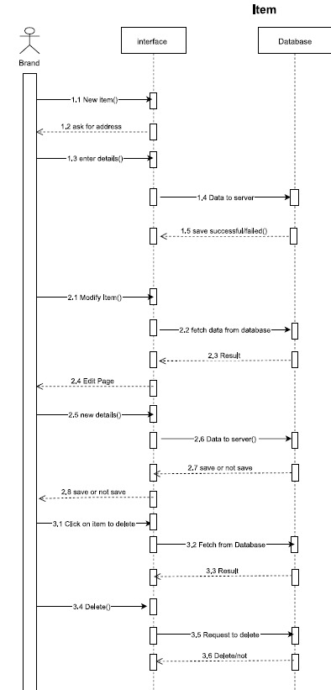

Figure 26:Item(Sequence Diagram)

**Description:**

This Figure describes the sequence to add a product within the system.

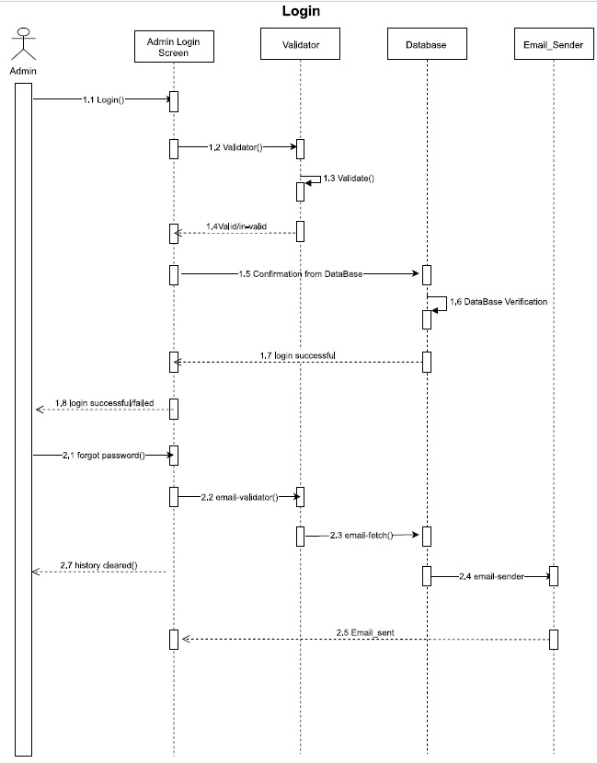

Figure 27:Login (Sequence Diagram)

**Description:**

This Figure describes the sequence of login within the system.

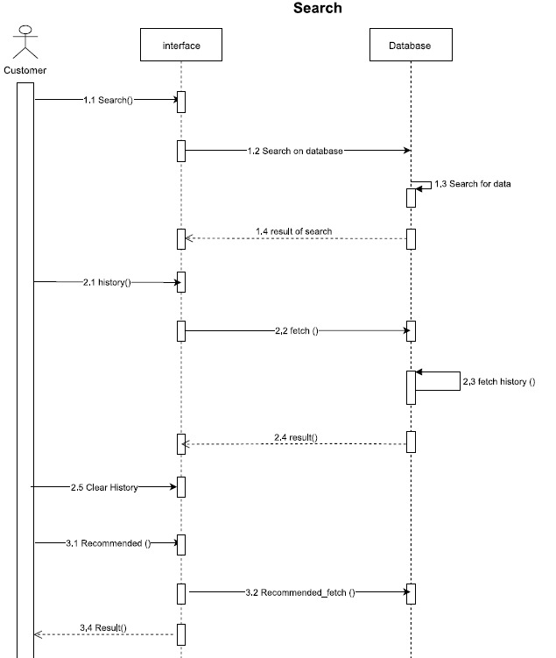

Figure 32:Search(Sequence Diagram)

**Description:**

This Figure describes the sequence of search within the system.

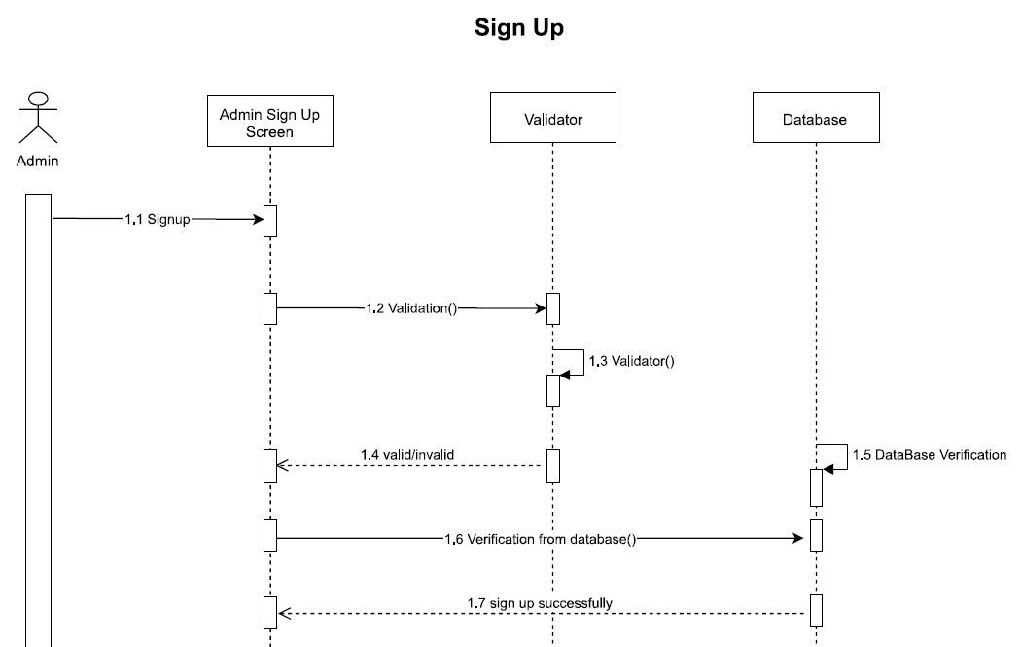

Figure 33:SignUp(Sequence Diagram)

**Description:**

This Figure describes the sequence of sign up within the system.

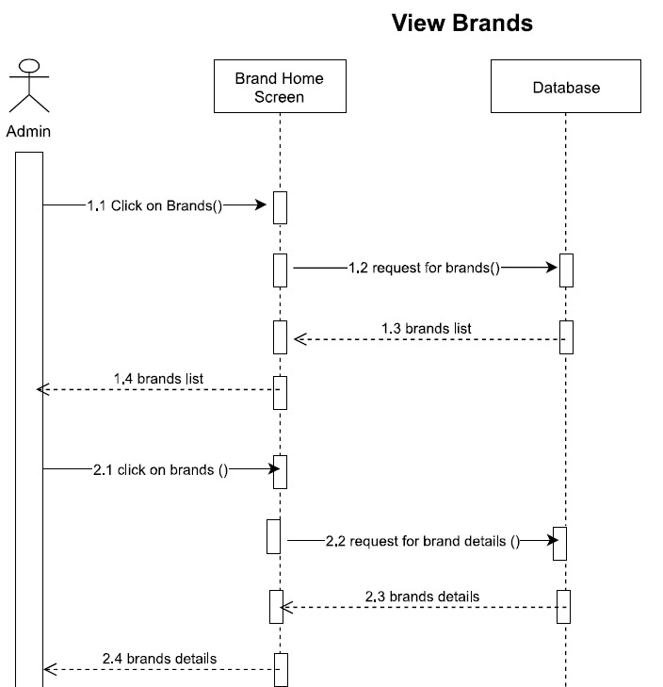

Figure 35:View Brands (Sequence Diagram)

**Description:**

This Figure describes the sequence to view the brands and it’s details within the system.

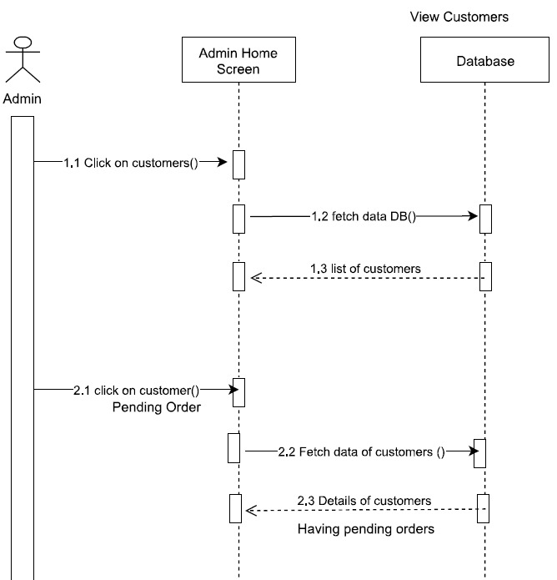

Figure 37:View Customer (Sequence Diagram)

**Description:**

This Figure describes the sequence to view the customer within the system.

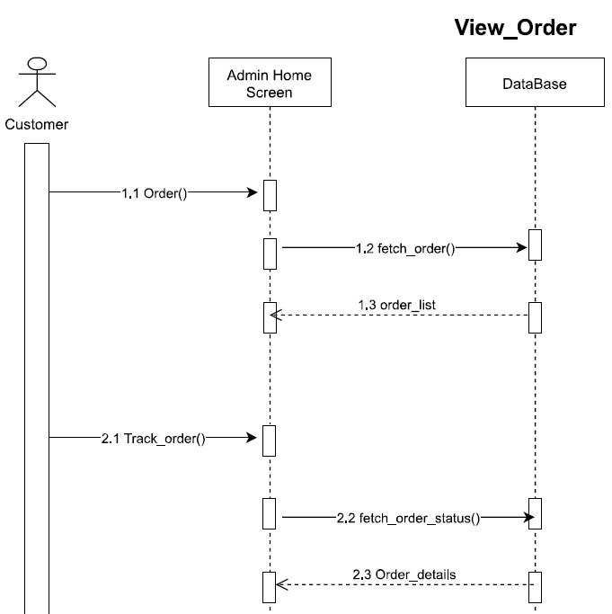

Figure 41:View Orders (Sequence Diagram)

**Description:**

This Figure describes the sequence to view the order within the system.

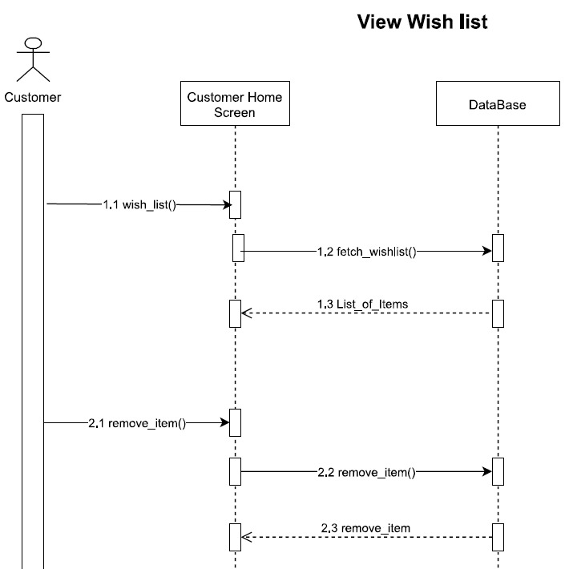

Figure 42:WishList(Sequence Diagram)

**Description:**

This Figure describes the sequence to add product in Wishlist within the system.

**2.8 Activity Diagram**

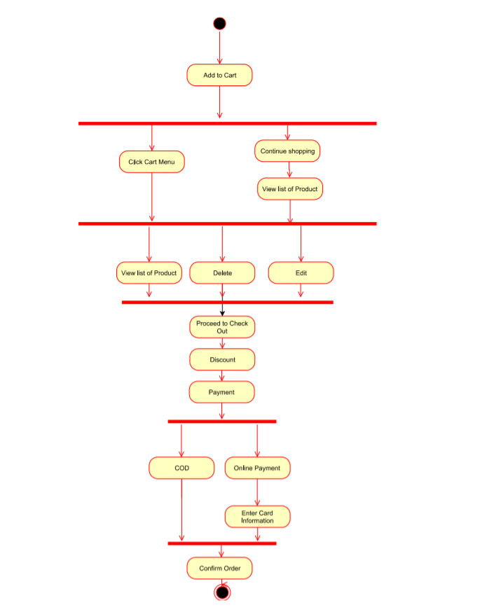

**Description:**

This Figure show the activity diagram that how user can add product to cart.

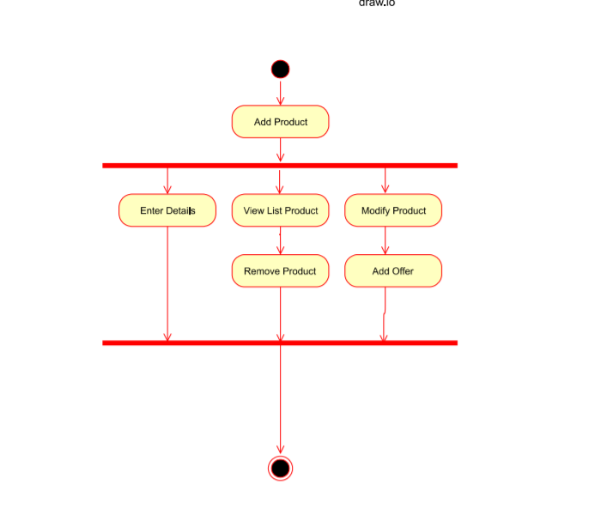

Figure 46:Add Product

**Description:**

This Figure show the activity diagram that how supplier can add new product in its store.

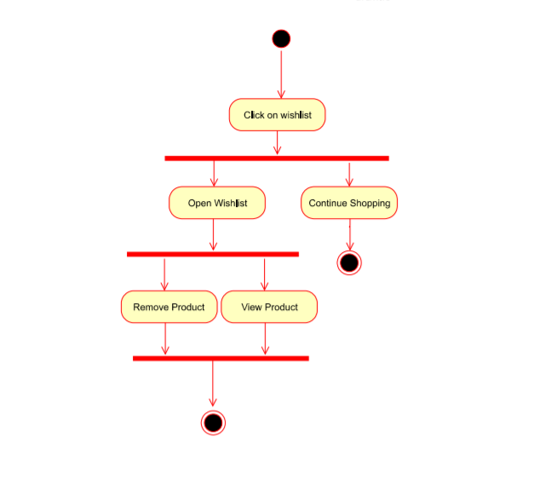

Figure 49:WishList

**Description:**

This Figure show the activity diagram that how customer can add new product in its Wishlist.

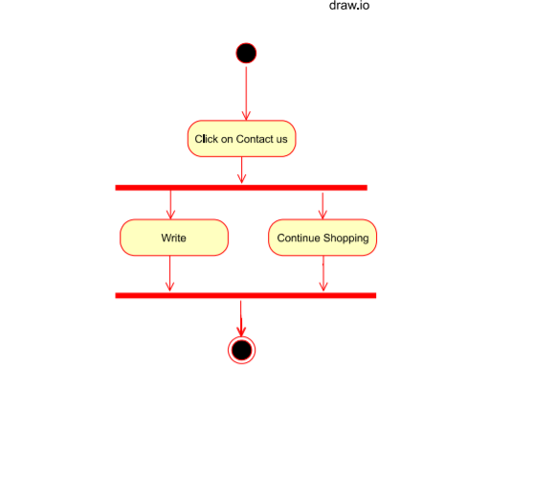

Figure 50:Contact us

**Description:**

This Figure show the activity diagram that how customer can contact the admin.

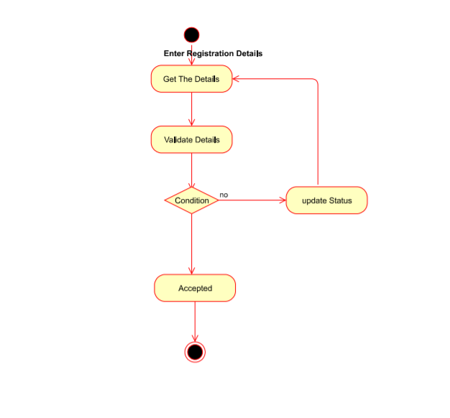

Figure 52:SignUp

**Description:**

This Figure show the activity diagram that how supplier, Customer can sign up.

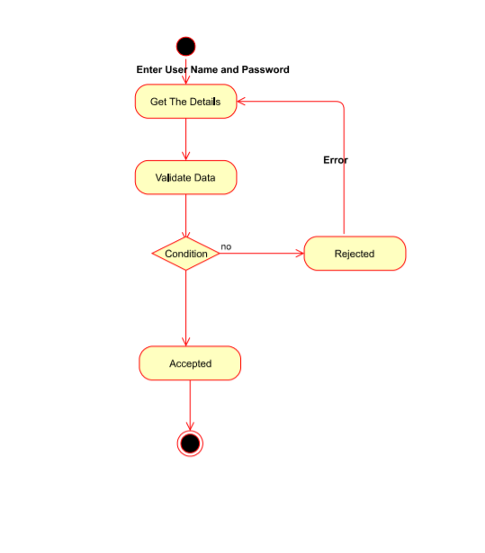

Figure 53:Login

**Description:**

This Figure show the activity diagram that how supplier, Customer, Admin can Login.

## Software architecture

ZJ motors system is a huge system, which is based on web-application, and .NET is use as tool and technology for its development, which is three-tier architecture and it is the layer structure architecture. This architecture is also similar to the client server architecture, or it is a specialization of client server architecture. So, these tiers are

1. Front end: This layer controls the front end of the site that contains interfaces. This part will work on HTML/CSS/JAVASCRIPT
2. Backend: It controls application functionality by performing detailed processing. This will work on .NET.
3. Database end: This layer contains servers where information is stored and retrieved. The database will be on MYSQL

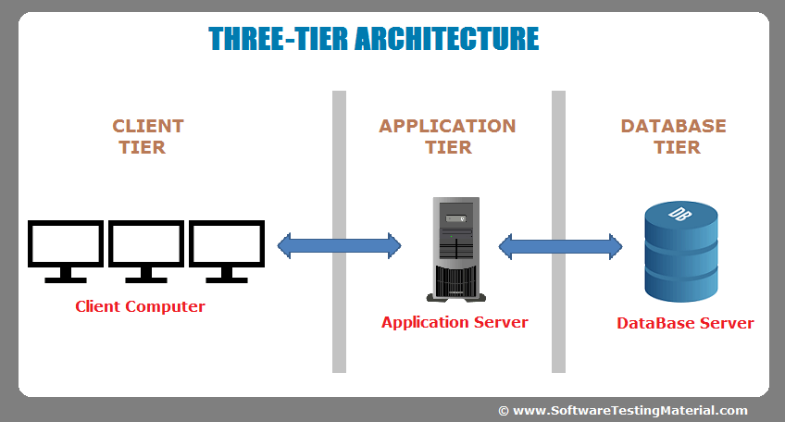

Figure 54:System Architecture Diagram

## Database diagram

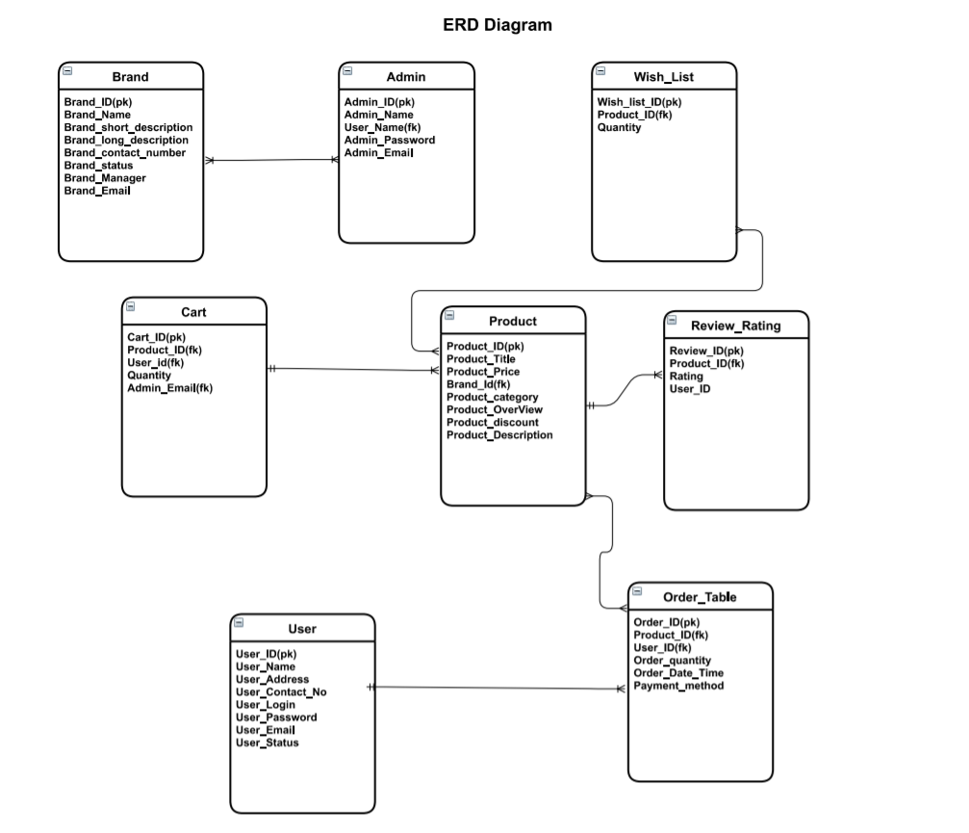

Figure 55:ERD

## Work Breakdown Structure

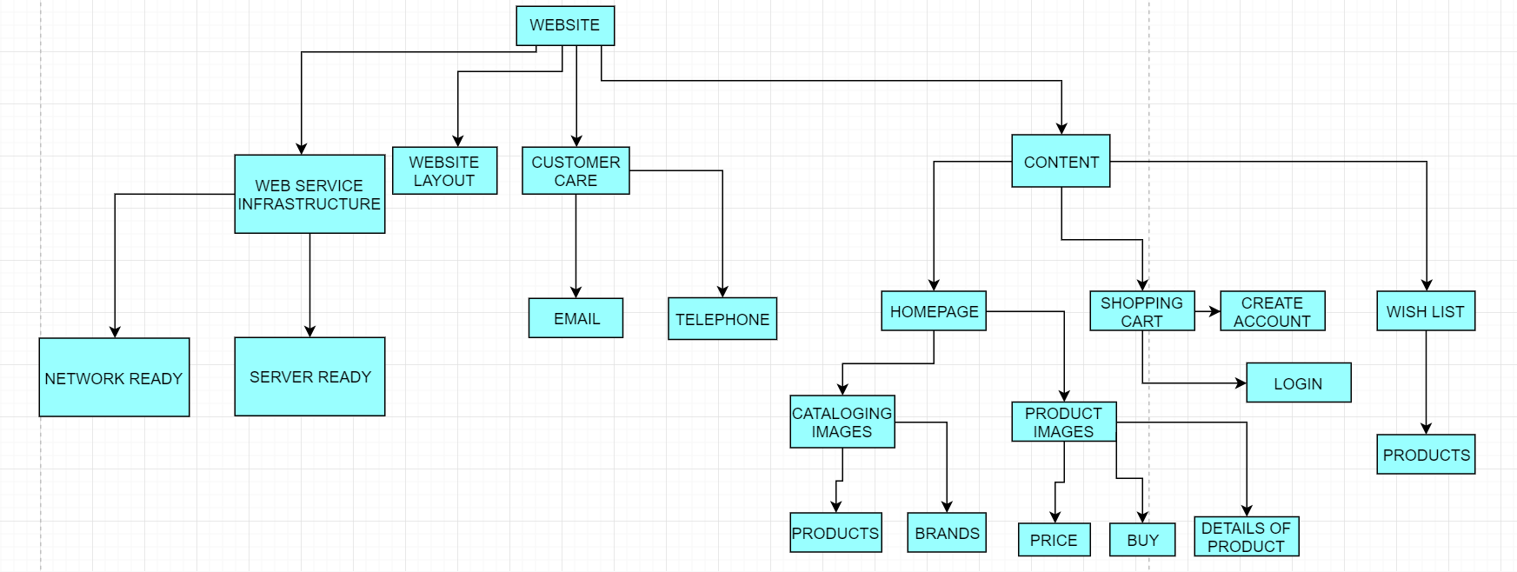

Figure 56:WBS

## Gantt chart

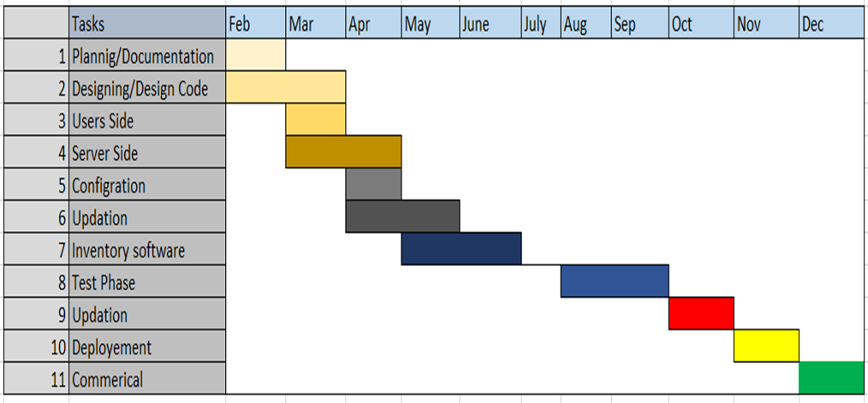

Figure 57:Gantt chart

# Conclusion

## Problems faced

**Problems Faced:**

* It was difficult to face how to create such interfaces which worked well for naïve users like children.
* Connecting the database with the interface that can be transported to any system at any time.
* Scaling of the interface.

**Lessons Learned:**

* Software development and project management.
* Division of work among the group members.
* Document writing.

## Project summary

We are developing an E-commerce store which would contain spare parts for Japanese cars and also you can search your area and it would show the best mechanics around you along with the ratings. Also it would contain data of some popular car websites so you can compare your spare parts prices on all those stores. Plus check where the part is available.

## Future work

This project basically on the web and android. So, our aim is to make it a mature IOS application which will deployed on the market. Our future aim is to try make it market product by its advertisement and focus to collaborate with more brands by applying different market strategies.

**References:**

No references.